BOOKING FORM (continued)

OHTA Conference 2017
Organ Historical Trust of Australia
PO Box 200, Camberwell, Victoria 3124, Australia
Name……………………………………………..
Address…………………………………………..
……………………………………………………
Phone…………………………………………….
Email…………………………………………….
Number being paid for …………………………
Additional names being paid for:
……………………………………………………
Early Bird (by 30 June) Student
Standard (after 30 June but by 7 August)
Late (received after 7 August) $100 extra

Day Rate: days 1 2 3 4 5 6
TOTAL BEING PAID A$ …………………….

Full conference fees include all events, conference book, a special commemorative publication, coach transport Wednesday to Saturday, minibus as required on Tuesday, accommodation Friday 29 September (including breakfast), 2 lunches and 1 dinner (Friday).

Note that refunding of conference fees owing to withdrawal will not be possible after Friday 1 September.
PAYMENT METHODS

Direct bank transfer to OHTA’s ANZ Account at Royal Bank branch BSB: 013128 Account: 204705424 [Swift code: ANZBAU3M]. To identify the transaction to us, please use your last name and CONF.
Credit Card: □ Visa or □ MasterCard
Card number (please write clearly)

_ _ _ _ /_ _ _ _ / _ _ _ _/_ _ _ _

Expiry __ __ / __ __ CCV (back of card) __ __ __

Name on card (please print)

………………………………………………………......

Signature…………………………… Date __ / __ / __

Cheque to “The Organ Historical Trust of Australia”

ACCOMMODATION – FRIDAY 29 SEPTEMBER ONLY
Single room Twin share Double room
Name of person with whom you intend sharing:

………………………………………………………......

DIETARY REQUIREMENTS
Please specify any food allergies or dietary requirements

………………………………………………………......

WALKING
The conference will include walking on day two for around 3.5 km stopping at a number of venues
I will require minibus transport on this day

PREFERRED NAME ON NAME TAG

………………………………………………………......

Organ Historical Trust of Australia
ABN 99 005 443 372

OHTA at 40 /
FOCUS on FULLER

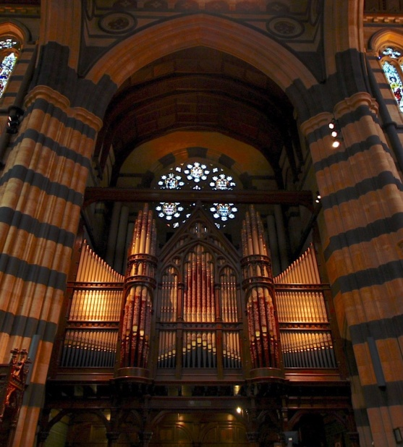

40th Annual Conference
25 – 30 September 2017

Melbourne & Ballarat region
VICTORIA AUSTRALIA

www.ohta.org.au
OHTA at 40 /
FOCUS on FULLER
40th Annual Conference

OHTA’s 2017 conference will celebrate the 40th anniversary of the foundation of the organisation in May 1977 as well as focussing upon the work of 19th-century Melbourne organbuilder Alfred Fuller (1845-1923). There will be papers and panel discussions associated with both themes.

The conference will also include visits to significant instruments, not only by Alfred Fuller, but also by Alfred Crook, George Fincham, Balbiani, Harrison & Harrison, Kenneth Jones, Samuel Joscelyne, Henry Willis & Sons, J.W. Wolff, Hill, Norman & Beard, Halmshaw and Hamlin. The programme will include a number of organ recitals, and an optional visit to the Grainger Museum.

PROGRAMME SUMMARY

Monday 25 September: Melbourne CBD. Registration 9.00 am at St Paul’s Cathedral. Papers and presentations on OHTA’s 40-year history. Lunchtime recital at St Paul’s Cathedral. Visits to organs in West Melbourne (Fincham) and South Melbourne (Henry Willis & Sons).

Tuesday 26 September: Melbourne – north of the city area. OHTA AGM and visits to organs in Fitzroy (Harrison & Harrison), Carlton (Balbiani and Fincham), Parkville (Fincham & Hobday, Kenneth Jones and Fincham) and optional tour of the Grainger Museum.

Wednesday 27 September: Alfred Fuller day, Melbourne western, northern and eastern suburbs. Visits to organs in Flemington, North Fitzroy, Heidelberg and North Blackburn, three of which have been relocated.

[Draft date 10 March 2017]
Thursday 28 September. Melbourne southern and eastern suburbs. Visits to organs in East St Kilda (Fincham and Joscelyne), Caulfield (J.W. Wolff), Caulfield South (A.Crook) and concluding with a recital at Scotch College, Hawthorn (Hill, Norman & Beard).

Friday 29 September: Melbourne to Creswick. Visits to organs in Craigie (Halmshaw), Talbot (Fincham), Clunes (Francis Nicholson and Hamlin) and Creswick (Fincham & Hobday). Night’s accommodation Creswick included.

Saturday 30 September: Ballarat. Visits to organs by Fincham & Hobday and George Fincham & Sons. After lunch, the coach will return to Melbourne via airport arriving there by 3.00 pm and then to the city.
ACCOMMODATION
You will need to book your own accommodation in Melbourne for five nights 24-28 September.

A block booking for OHTA has been made at the Ibis Melbourne Hotel and Apartments, 15-21 Therry Street, Melbourne, but you must contact the hotel directly before 30 June 2017 to ensure a preferential rate, quoting code: ‘OHTA40’. Room only cost per night is $125.00 (max 2 per room). Contact Andrew Singer (Reservations Manager), email H1564-RE2@accor.com or telephone 03 9666 0000. Breakfast can be reserved at a reduced rate ($16.00 per day) at the time of booking.

Accommodation for one night only (Friday 29 September) has been reserved at the RACV Goldfields Resort, Creswick, north of Ballarat, and is included in the conference registration together with dinner.

As the final day of the Conference coincides with the AFL Grand Final, your accommodation and transport to Melbourne should be given high priority.

Participants must arrange their own travel to and from Melbourne.
FURTHER INFORMATION
Contact - Christopher Cook, accook2001@yahoo.com.au

OHTA cannot guarantee Creswick accommodation or coach transport for registrations received after 7 August 2017.

BOOKING FORM
Please tick the appropriate box below:

 | Member | Non-Member
Early Bird single | $770.00* | $830.00#
Standard single | $820.00* | $880.00#
Early Bird twin/double pp | $700.00* | $760.001#
Standard twin/double pp | $750.00* | $810.00#
Early Bird rate if received by 30 June
Late (received after 7 Aug): Standard rates above + $100
* = Reduced rate for OHTA Members.
# = Rate for non-members, includes one-year membership

Full-time student – under the age of 25 applying for a bursary covering full registration and accommodation – Note: attach a copy of your student identification card

DAY RATES
The day rate (per person) is $80 per day and includes day events, a conference book – Friday / Saturday coach and accommodation not included.

TRANSPORTATION

Coaches will be used from Wednesday to Saturday and will leave outside the Ibis Hotel in Therry Street. On the Monday and Tuesday, public transport via tram can be used, using a Myki card which you must purchase yourself before the conference.

Illustration: St Paul’s Cathedral, Melbourne – the 1891 T.C. Lewis organ (Simon Colvin)

